**MR. AND MS. TEEN GUIMBAL 2025**

**GENERAL RULES AND GUIDELINES:**

1. All participating contestants must be enrolled at their respective school in the district of Guimbal.

2. Each school must delegate contestants to represent their school endorsed and approved by the school head.

a. Nalundan NHS – 1 Pair

b. Particion NHS – 1 pair

c. Camangahan NHS – 1 Pair

d. Guimbal NHS – 1 Pair

e. CSRIS & NIS – 1 Pair

|  |  |  |  |  |
| --- | --- | --- | --- | --- |
| ***CONTESTANT NO.*** | ***MALE*** | ***FEMALE*** | ***SCHOOL*** | ***COACH/ES*** |
| **1 PNHS** |  |  |  |  |
| **2 CNHS** |  |  |  |  |
| **3 GNHS** |  |  |  |  |
| **4 NNHS** |  |  |  |  |
| **5 IS** |  |  |  |  |
|  |  |  |  |  |

3. Participating schools shall have four coaches for each pair who will accompany the candidates during their scheduled rehearsals, and other related activities.

a. On the day of the competition, ***only 2 coaches, 1 make-up artist and 1 assistant*** will be allowed inside the holding area.

4. The organizing committee has the right to call the attention of the candidates in cases of any untoward behavior that would cause disturbance of the scheduled activity. In case the candidate will not comply or will not follow the instructions and directions, he/she will be removed from the competition.

5. Candidates, make-up artist and coaches should strictly follow the designs of attire and costumes in each category. ***Non-compliance would result to candidate placed last in that area of the competition.***

6. Rank system will be used to determine the winners.

7. The decision of the judges is final and irrevocable.

*CONCEPT:* ***“Ascend: Rising Beyond Beauty”***

“Ascend: Rising Beyond Beauty” embodies the spirit of Guimbal—the Town of the Rising Sun and Sons—where strength, radiance, and potential are ever-present. This year’s pageant celebrates a new generation of teens who rise with purpose, confidence, and character.

More than showcasing physical charm, **ASCEND** represents growth, transformation, and the courage to reach one’s highest self. It honors young individuals who elevate not only their talents and intelligence, but also their compassion, leadership, and commitment to community.

In this journey, every candidate is invited to **ascend**—to shine brighter, strive higher, and redefine what true beauty and excellence mean for the youth of Guimbal.

CATEGORIES

**1. PRODUCTION NUMBER:**

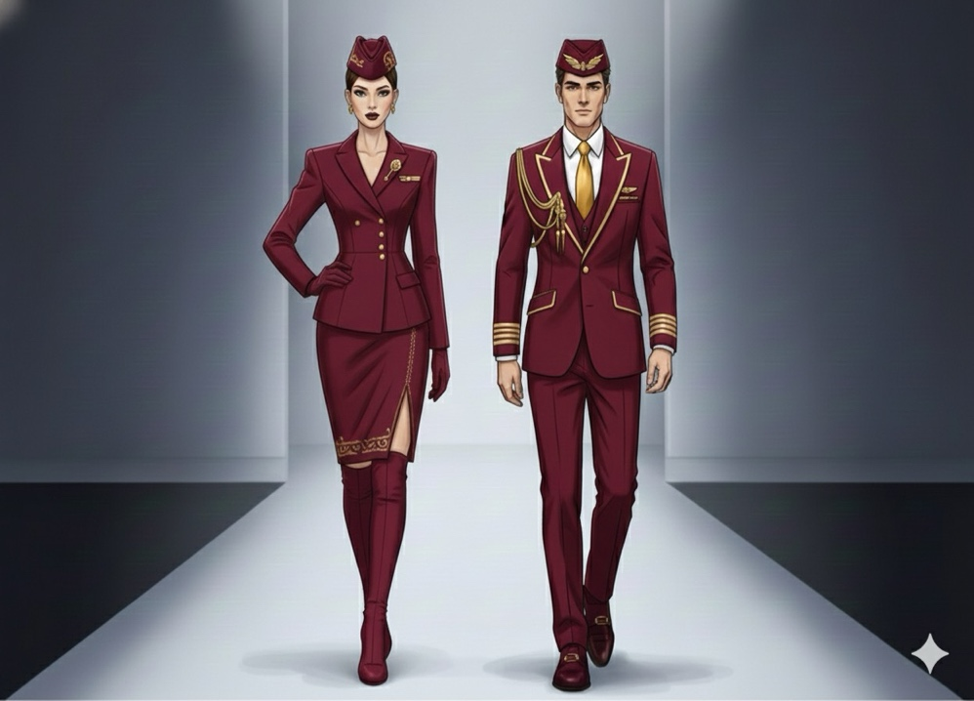**Concept: “Altitude 2025”**

a. Each candidate is designed to a specific opening outfit that will be facilitated by the organizer.

b. For female candidates, they will match their outfit with **gold stud earrings** and gold boots. For male candidates, they will match the upper garment with white inside long sleeve paired with brown formal shoes.

b. Candidates are not allowed to add back dress. Head piece is limited to the forage cap or garrison cap/hat used by cabin crew (as what is seen on the sample image). No other accessories.

c. In the introduction, candidates will introduce themselves in pairs.

d. Production speech is limited to CHRISTMAS GREETINGS (2 sentences only), NAME and SCHOOL REPRESENTING.

**CRITERIA**

Poise and Bearing – 30 %

Stage Deportment – 35 %

Mastery of the choreography – 30 %

Audience impact – 5%

**2. RUNWAY**

**Concept: DENIM REIMAGINED**

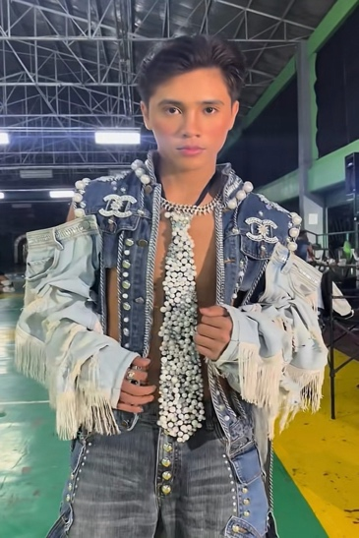It transforms a timeless fabric into a vision of elegance, innovation, and bold identity. In this segment, denim sheds its casual skin and takes on a new form—elevated by the sophistication of pearls, sculpted silhouettes, and couture-level craftsmanship.

a. Candidates can freely create their high fashion couture-style costume in denim fabrics embellished with pearls ONLY.

b. Costumes must be suitable to the age appropriation of the audience, not too vulgar and not too daring.

c. Back dress and capes attached at the back or on the hand are not allowed.

d. No Hand props. No Headdress. No shades or anything that covers the eyes or the face.

e. Footwear must be suitable to the costume. Heels are not allowed, for female candidates (only boots/sandals/gladiators) are allowed.

f. Accessories are allowed if it is suited to the costume as long as it is constructed with the use of pearls.

**CRITERIA**

Creativity and style – 30%

Personality and Stage presence – 20%

Suitability of the costume – 30 %

Poise, bearing and projection- 20%

**3. STREET WEAR**

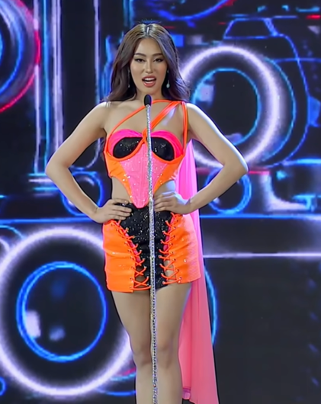**Concept: “Chromatic Royals: Flight of the New Sun”** (A bold fusion of modern royalty + neon aviation energy) This ties visually to Guimbal: Town of the Rising Sun and Sons, by depicting the contestants as the new rising royals — captivating, radiant, alive.

a. Each candidate is designed to a specific outfit that will be facilitated by the organizer.

b. For female candidates, they will match their outfit with ***SILVER dangling earrings*** and their heels.

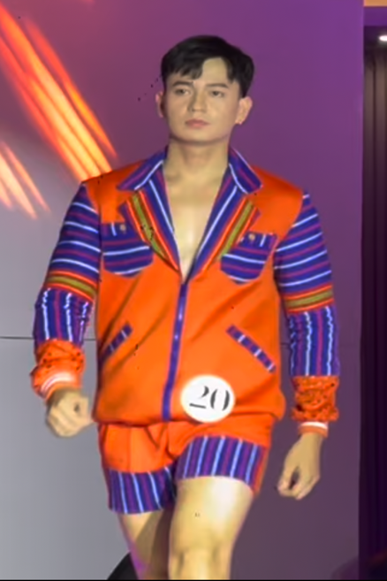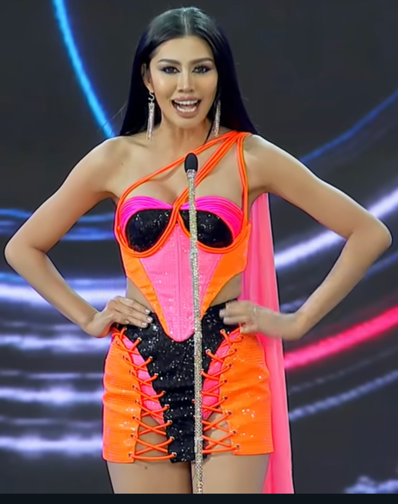c. For male candidates, they must wear ***white chunky sneakers.***

d. Candidates are not allowed to add back dress or headpiece. No other accessories.

**CRITERIA**

Beauty and Physique- 30 %

Stage Deportment – 30 %

Poise and bearing – 30%

Audience impact – 10%

**4. FREE SPEECH**a. The Free Speech’ goal is to uphold the spirit of Ascend: Rising Beyond Beauty, and to honor Guimbal as the Town of the Rising Sun and Sons, this pageant promotes a culture of dignity, encouragement, and responsible self-expression.

b. The Free Speech must contain:

a. ***Speak Respectfully*** - Honor fellow candidates, the audience, and the community in your words and tone.

b. ***Express With Purpose-*** Share ideas that inspire growth, hope, and transformation.

c. ***Be Authentic*** - Speak honestly from real experiences, values, and advocacy.

d. ***Stay Uplifting*** - Promote kindness, unity, and encouragement—even in personal challenges.

e. ***Honor Guimbal*** - Reflect pride in our cultural identity as the Town of the Rising Sons and Suns.

f. ***Empower Others*** - Use your voice to enlighten, not diminish; to motivate, not divide.

c. The duration of the speech must be within 3 to 5 minutes. Excess time will be equivalent to deduction to the candidates’ talent scores for every judge. One point if it exceeds the time limit and another one point for every second excess time.

d. The Free Speech will be showcased by pair, but they will be judged individually.

e. English, Filipino, Kinaray-a or the combination of these languages are accepted and recognized.

f. School Uniform will be used in this category.

**CRITERIA**

Content & Substance (clarity, relevance, message) 40%

Delivery & Presence (confidence, voice, timing) 30%

Alignment to “Ascend” Theme (growth, inspiration, purpose) 20%

Respectfulness & Positivity 10%

**5. MODERN BARONG AND LONG GOWN**

**T’nalak-Inspired Concept: “Ascend in Heritage: Threads of Tradition, Rise of Tomorrow”**

This segment embodies the upward journey of cultural pride and modern identity.**transformation—the Modern Barong and Long Gown category celebrates the timeless soul of Filipino heritage while ascending into a contemporary vision of beauty.

The candidates become living canvases of culture—ascending beyond mere aesthetics, honoring craftsmanship, and carrying forward the identity of the Filipino spirit.

***Please Keep in Mind:*** T\'nalak weaving is a traditional cloth-making technique of the T\'boli people in the Philippines, where sacred patterns are created using an ikat dyeing process on abaca fibers. The cloth is known for its ***tri-color scheme of red, white, and black***, and the designs are said to come to the weavers in dreams from the Fu Dalu, the spirit of the abaca plant. The process is rich with ritual and tradition, and each piece is painstakingly created over weeks or months.

**Guidelines *(T’nalak-Inspired Edition)***

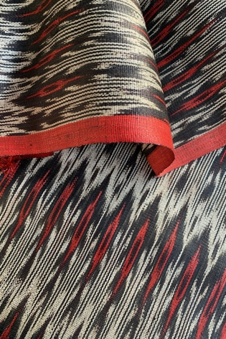a. For female candidates, the long gown must be in a serpentine style with long sleeves and no petticoat. The fabric to be used in the construction and detailing of the gown must be in all T’nalak inspired fabric. No hair and hand accessories. No capes. No back dresses. They will use their heels.

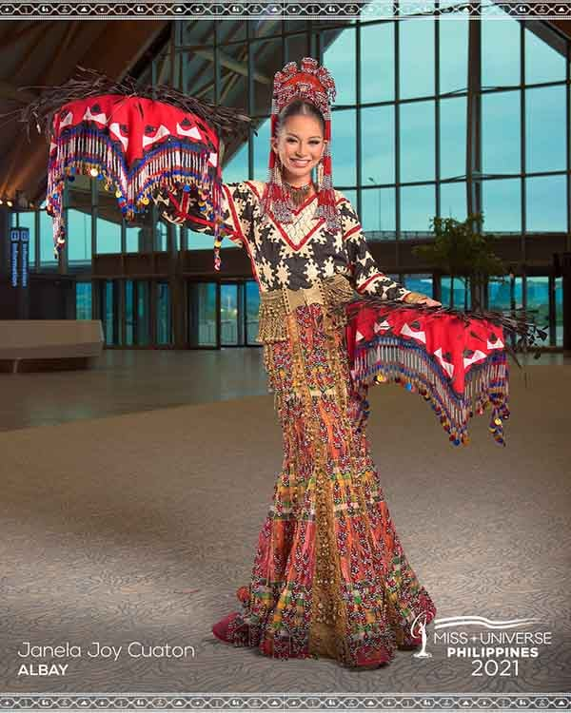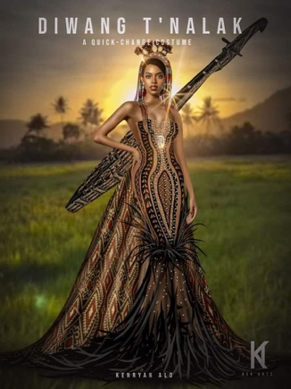

Note: The cut of the gown must be the same with the images provided.

b. For male candidates, they will be also wearing a set of modern barong and pants created and crafted with T’nalak inspired fabric and a choice of their formal closed shoes. No hair and hand accessories. No capes. No back dresses.

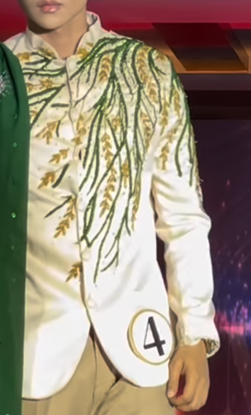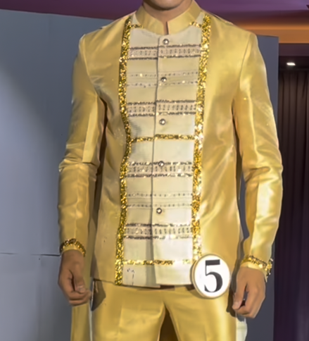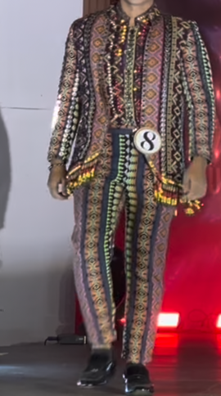

Note: The cut of the modern barong is shown in the sample images.

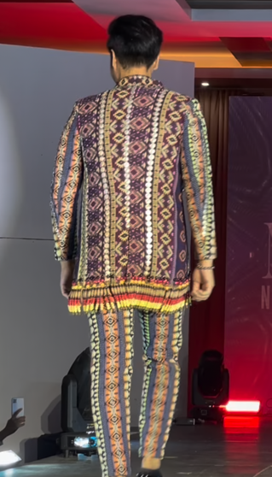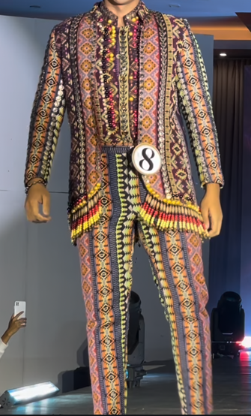

c. Both candidates must wear the same fabric design.

**CRITERIA**

Fitness and style – 20 %

Beauty and Elegance – 30 %

Stage Deportment – 25 %

Poise, bearing and projection – 25%

**6. INTERVIEW**

a. The interview questions will be formulated by the organizing committee.

b. The contestants will be given words or phrases as guide for practice in this category.

c. Candidates can freely convey their answers in English, in Filipino and in Kinaray-a.

**CRITERIA**

Wit and content – 50 %

Delivery and choice of words – 25 %

Poise and bearing – 15 %

Audience Impact – 10%

**PICTORIAL AND VIDEO SHOOT**

**December 07, 2025 (8:00 am – 5: 00 pm)**

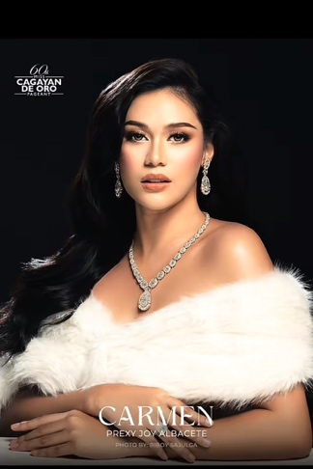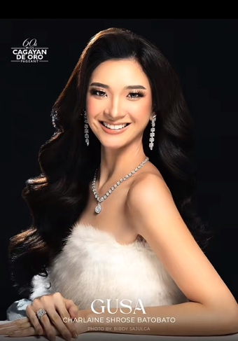

Venue: Guimbal NHS

LAY-OUT NO. 1: HEADSHOT

FEMALE: White tube with fur details matched with silver necklace, earrings, and ring.

MALE: Topless with silver chain necklace.

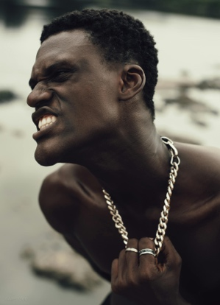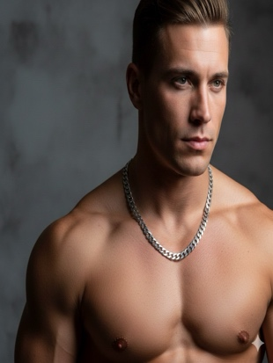

LAY-OUT NO. 2: VIDEO SHOOT

FEMALE: White flowy long dress

MALE: White long sleeve and white pants

Note: No other accessories except for the accessories used during the headshot.

What to prepare:

1. Food for your contestants.

2. Service for your contestants.

**Reminders:**

* Candidates, all coaches, 1 make-up artist are allowed during the pictorial.
* Follow the concept of the photoshoot.
* Contact Lens is not allowed.

**Special Segment**

**Runway Challenge**

Guidelines:

a. Each candidate must submit a 1-minute video showcasing their skill in catwalk. Video shoot must focus on the candidate’s pasarela not the face or the body.

b. The video must be taken in a busy public place with people in the area.

b. The video will be in landscape setting with 1080 resolution. The video will be evaluated by the committee and non-compliance with the said setting of the video will result to repetition of the output.

c. On the video, it must include the name of the candidate and the school representing. This must be seen in the first 5 seconds of the video.

d. Candidates must be in their chosen leather outfit style (in any color).

e. This video will be shown on the LED screen on the day of the contest and winners will be receiving a special award: **Best in Runway for Male and Female**.

f. Deadline of the video will be on December 15, 2025 (until 12 noon). Uploaded on the google drive and send the link to Sir Kenneth Roy Montehermoso (FB: Kenneth Roy).

Prepared by:

**ROY M. BUENVIAJE**

Over-all In-Charge

Noted by:

MARISOL G. MAMON

Head Teacher In-charge

Approved by:

**ZALDY M. TONDO, PhD TESA F. GULANES**

Principal III Principal I

Guimbal National High School Nalundan National High School

**MA. SYLVIA D. NAPATANG REYNOR CERVANTES**

Principal I Principal II

Particion National High School Camangahan National High School

**CESAR ESTABALAYA DIANNE RHOVI G. SUMPIA, PhD**

Principal II Principal II

Cabasi-Sta. Rosa Integrated School Nanga Integrated School